Mid-Semester Report
Term Project
Team Leader: Ayushi Sharma
Team Members: Aditya Singh, Riddhi, Tenzin, Ravi Kasotiya, Gangothri

Title
Material Balances for Ammonia Production via Haber Process with Recycle and Purge

Abstract
The objective of this project is to perform detailed material balance calculations for the ammonia synthesis process using the Haber method, which includes recycle and purge streams. The process is inherently limited by low single-pass conversion, making the inclusion of recycle essential to increase overall yield. A purge stream is required to avoid inert gas accumulation. This report presents the process flow diagram, governing material balance equations, and the effect of reactor conversion and purge ratio on ammonia yield.

Introduction
Ammonia is an essential industrial chemical, widely used in fertilizers and explosives. Its production is dominated by the Haber process, where nitrogen reacts with hydrogen at high pressure and temperature in the presence of a catalyst. Due to equilibrium limitations, only 20–30% of the feed reacts in a single pass. Therefore, unreacted gases are separated, recycled, and partially purged to avoid buildup of inerts. This project focuses on material balance derivations for such a system.

Process Flow Diagram
The process consists of the following units:
1. Fresh Feed: Nitrogen, hydrogen, and small fraction of inerts.
2. Reactor: Converts a fraction of N2 and H2 into NH3.
3. Separator: Ammonia is removed; unreacted gases exit.
4. Recycle Stream: A fraction of gases are sent back to the reactor.
5. Purge Stream: A small fraction is purged to prevent inert accumulation.
A detailed schematic for the process is given below:
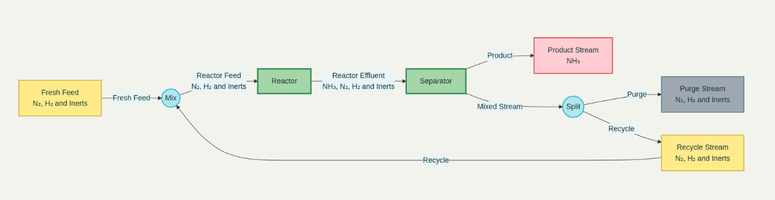

Material Balance Derivations
Assumptions:
• Basis: 100 mol fresh feed (N2 + 3H2 + Inerts).
• Reactor single-pass conversion: 25%.
• Purge ratio: 10%.
• Ideal separation: All NH3 is removed in the separator.
Reactor Balance:
Let x be the single-pass conversion of N2. For basis 100 mol feed:
N2 converted = 0.25 * N2_in
H2 consumed = 3 * N2 converted
NH3 formed = 2 * N2 converted
Separator Balance:
All NH3 is separated as product. Remaining gases (N2, H2, inerts) exit.
Recycle and Purge:
Unreacted gases = (1 - purge fraction) recycled + purge fraction removed.
Overall Balance:
Overall NH3 production = function of x and purge ratio.
The general relationship is derived in tabular form in the Results section.

Results and Discussion
The effect of reactor conversion and purge ratio on ammonia yield was studied. Higher conversion directly increases NH3 yield, but due to equilibrium limitations, conversion cannot be increased arbitrarily. Recycle improves effective conversion, while purge prevents inert accumulation but reduces NH3 recovery.
Sample results:
• At 25% conversion and 10% purge: NH3 yield = 33 mol per 100 mol fresh feed.
• At 30% conversion and 5% purge: NH3 yield = 40 mol per 100 mol fresh feed.
• At 20% conversion and 15% purge: NH3 yield = 25 mol per 100 mol fresh feed.
Graphs of conversion vs yield and purge ratio vs yield will be added in the final report.

Conclusion
This mid-semester report presents the basis of calculations for ammonia production using the Haber process with recycle and purge. Material balances for reactor, separator, and recycle/purge streams have been formulated. Preliminary results indicate that higher conversion and lower purge ratios increase ammonia yield. The final report will include complete sensitivity analysis, detailed graphs, and comparison with industrial data.

References
1. R. M. Felder and R. W. Rousseau, Elementary Principles of Chemical Processes, Wiley.
2. Himmelblau, D. M., Basic Principles and Calculations in Chemical Engineering.
3. J. M. Smith, H. C. Van Ness, and M. M. Abbott, Introduction to Chemical Engineering Thermodynamics.

